Q: Create a view to display the auction platform items with their details and the quantity.

create view INFO

AS Select p.productid 'PID', p.pname 'PName', p.color 'Color', p.size 'Size',p.ptype 'Type', p.baseprice 'Price',a.quantity 'Quantity'

FROM product p, auctionplatform a

WHERE p.productid = a.productid;

~~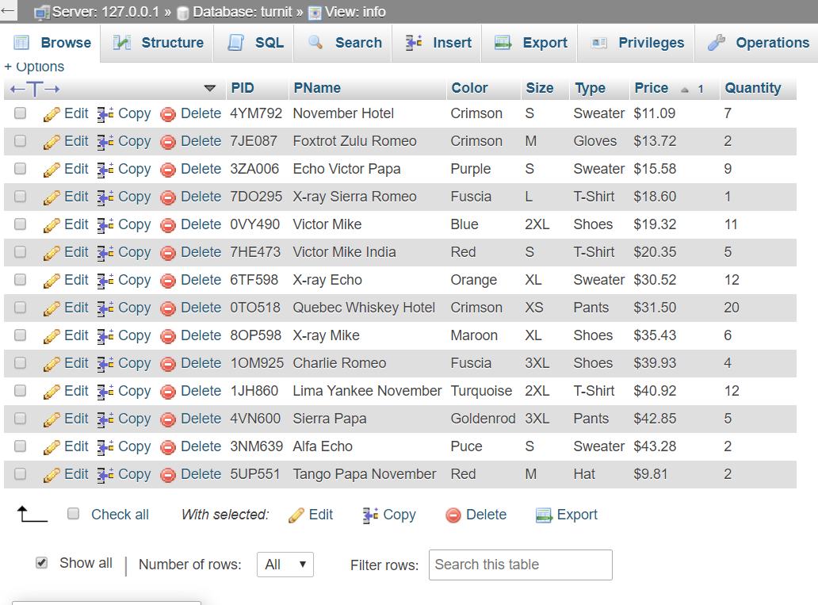~~

1. Show the products from the VIEW which are under the price of 22.22

SELECT \*

FROM info

WHERE SUBSTRING(Price,2,5) < 22.22;

~~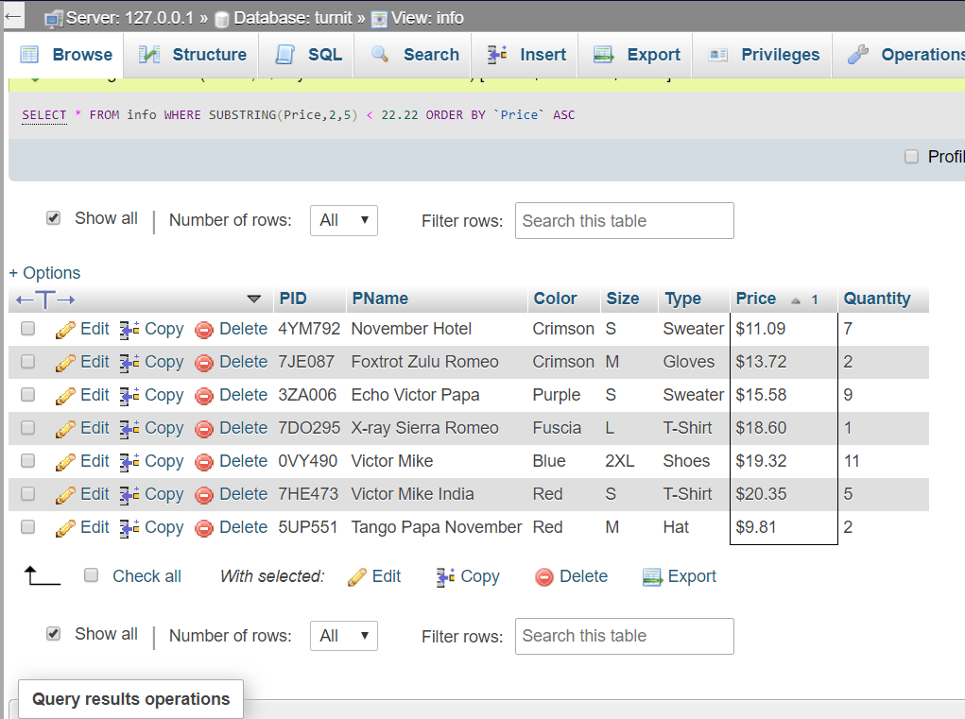~~

1. Show the products from the VIEW which are of ‘S’ Size

SELECT \*

FROM info

WHERE size = ‘S’;

~~